THE STORY OF NADDER COMMUNITY ENERGY

2007: Informal group Climate-friendly Tisbury: Ione Lacey, Maggie Paul, David Rear (Sue Reed after 2009).
2012: Sustainable Tisbury: Jules Gray, Jane, Maggie and Sue.
2014: Notice in Post Office window from Tom Burnett. Meeting at Parish Rooms and first steering committee set up with help from Community First: Jamie Meldau, Sue Reed, Maggie Paul, Ralph Perry Robinson, Tom Burnett, Amy Burnett. Tom got RCEF funding for feasibility study and Maggie introduced Hugh Synge, who became Chair with Tom as Co Sec.
2015: October registration of Nadder Community Energy as a community benefit society with board of directors: HS (Chair), TB (CoSec), Ralph, Sue, Maggie, Jamie. Launch of first Share Offer.
2016: Sue Reed took over as CoSec. Dick Ripper joined the board. Amy left.
2017: Tom left. Jamie left.
2018: Tim Plumptre and Kate Clark joined. Richard Ecclestone became Asset Manager. Hugh died.
2019: Second Share Offer. Alan Maryon-Davis and Lucy Stone joined. Dick and Ralph left. Jamie re-joined. Sue left as a director to become paid CoSec.
2020: Covid.
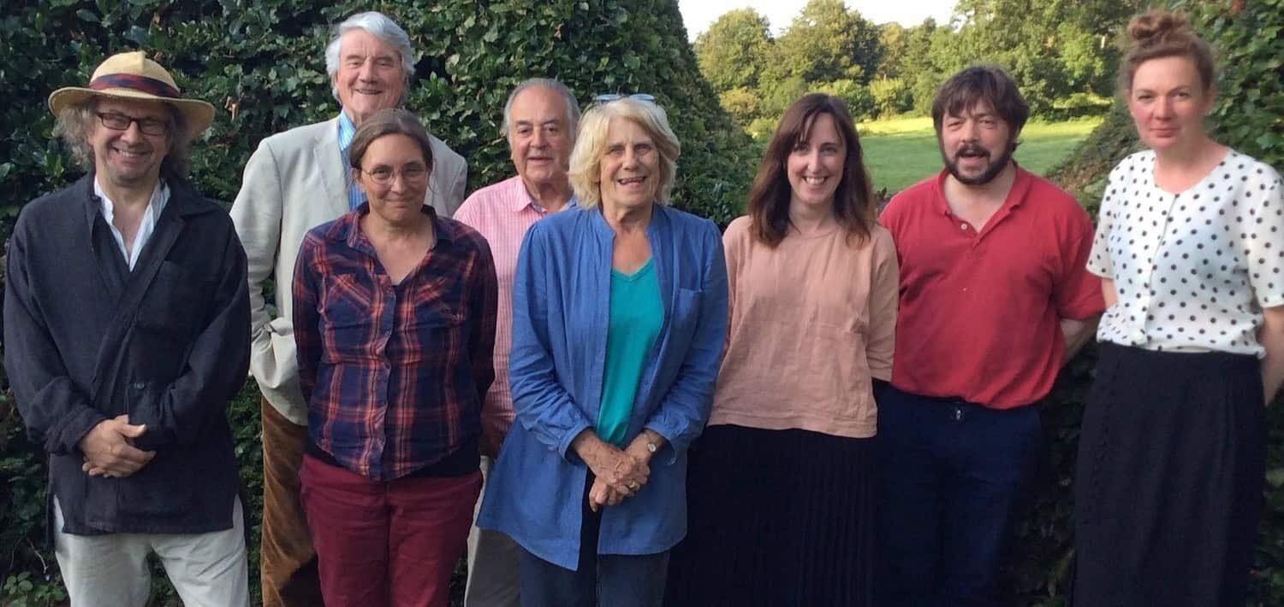
Jamie, Alan, Sue, Tim, Maggie, Lucy, Ralp and Kate.

2021: Tisbury Electric Car Club launched, led by Gus. Jamie and Kate left.
2022: Rosie Buck and Mike Simpkins joined.
2023: Warmer at Home scheme launched, led by Rosie. Mike and Lucy left. Peter Shallcross and Gustavo Montes de Oca joined. Tim died.
2025: Gus left the board, continuing as car club lead.

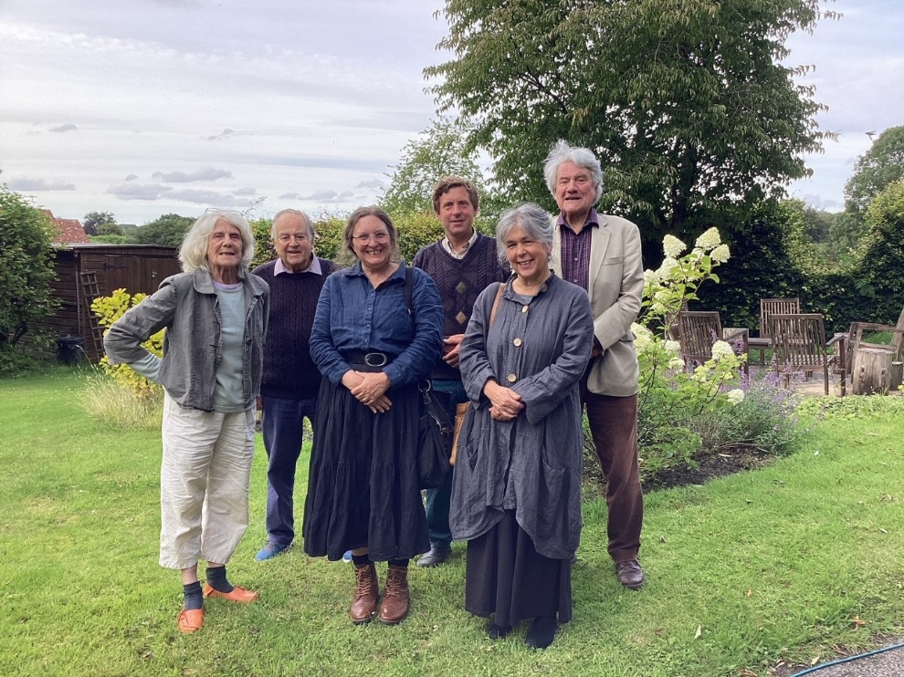
Maggie, Tim, Sue, Peter, Rosie and Alan

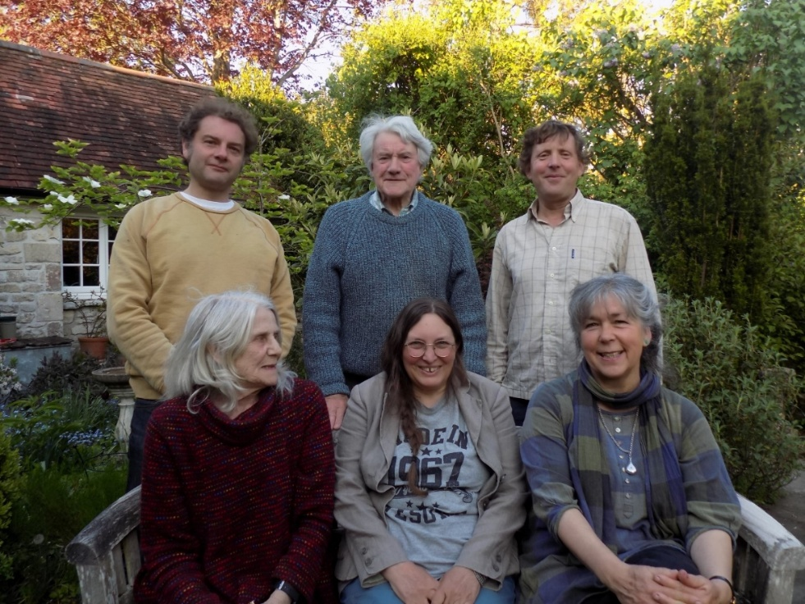
Gus, Maggie, Alan, Sue, Peter and Rosie

